25.60: a) 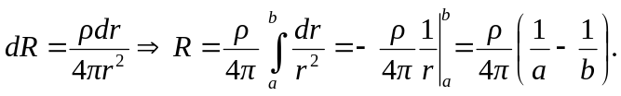
b) 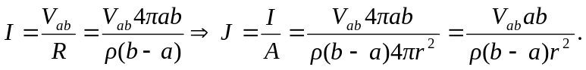
c) If the thickness of the shells is small, we have the resistance given by:
